**Analysis**

**Discipline Document**

**INF-F Analysis and Software Design**

**Project: HHS Term Planning**

**Date: 7-4-2014**

**Owner: Arif Munaf, Tim van der Meer**

**Version: 1.0**

**Document History**

**Revision History**

|  |  |  |
| --- | --- | --- |
| **Version** | **Revision date** | **Summary of changes** |
| 0.1 | 10-3-2014 | Added analysis class diagram |
| 0.2 | 12-3-2014 | Added analysis packages |
| 0.3 | 13-3-2014 | Updated class diagram to reflect packages |
| 0.4 | 25-3-2014 | Updated class diagram and added sequence diagrams |
| 1.0 | 7-4-2014 | Finalized document |

**Distribution**

This document is intended for:

|  |  |  |  |
| --- | --- | --- | --- |
| **Name** | **Function** | **Date of issue** | **Version** |
| Client | project owner | 7-4-2014 | 1.0 |
| Indian Coding Company | implementation of project | 7-4-2014 | 1.0 |

Table of Contents

1. Introduction 4

2. Analysis packages 5

3. Analysis class diagram 6

4. Analysis use case realizations 7

1. Introduction

This document provides a view on the baseline of our software structure. The package analysis describes the different packages that make up the essence of the system. The analysis diagram contains the essential classes that describe the contents of the packages. The diagrams in chapter 4 are meant to further illustrate certain parts of the system.

2. Analysis packages

Four different analysis packages have been identified,

* Task, containing all classes necessary for managing tasks and activities
* Location, contained in the Task package, specifies locations and their types
* Course, containing classes used for managing course parameters, groups and teaching units
* Teacher, specifying classes dealing with specializations and teachers

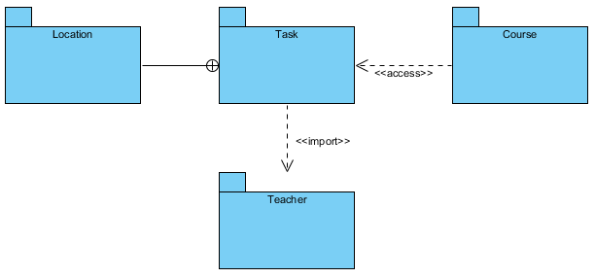

3. Analysis class diagram

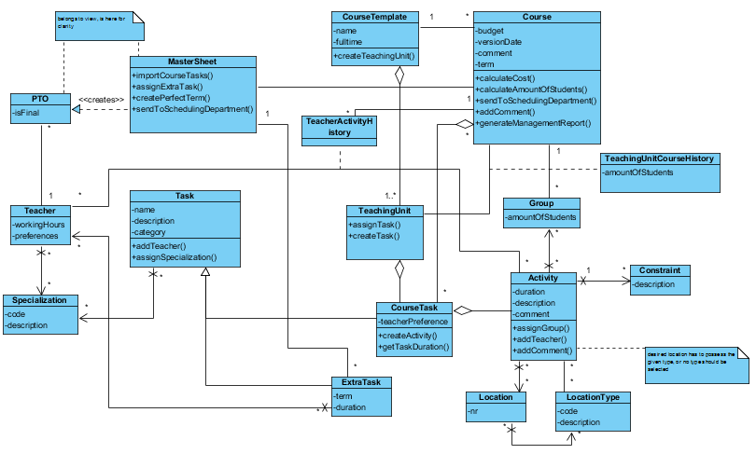

For a better view, check the appended documents.

4. Analysis use case realizations

Note that all of the following diagrams are also contained in the appended documents.

This diagram shows the process of adding a teacher to a task, making sure the teacher has the correct specializations.

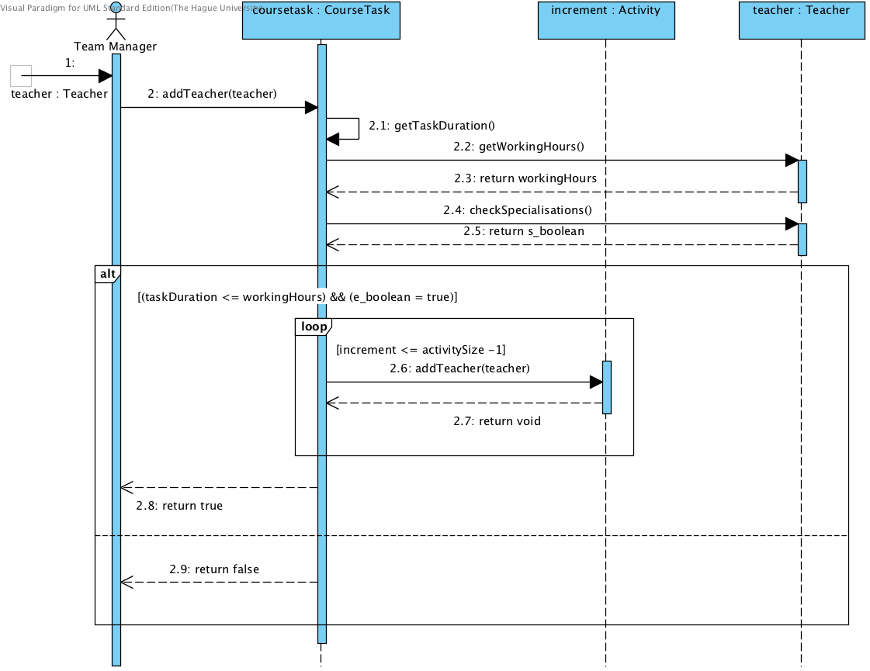

This diagram shows how the course manager goes about designing a course parameter.

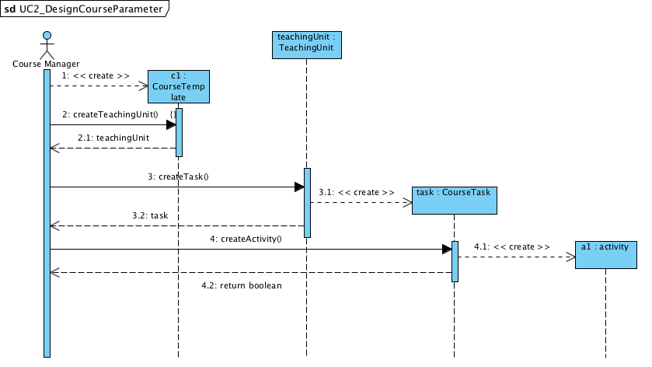

The diagram below shows the process of generating a management report.

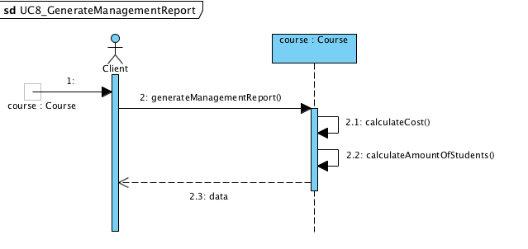

The following state diagram describes the state of the location when a course manager wants to add a preference of location type for an activity with required states for scheduling activities by the scheduling department.

